The Love of Running and Beer

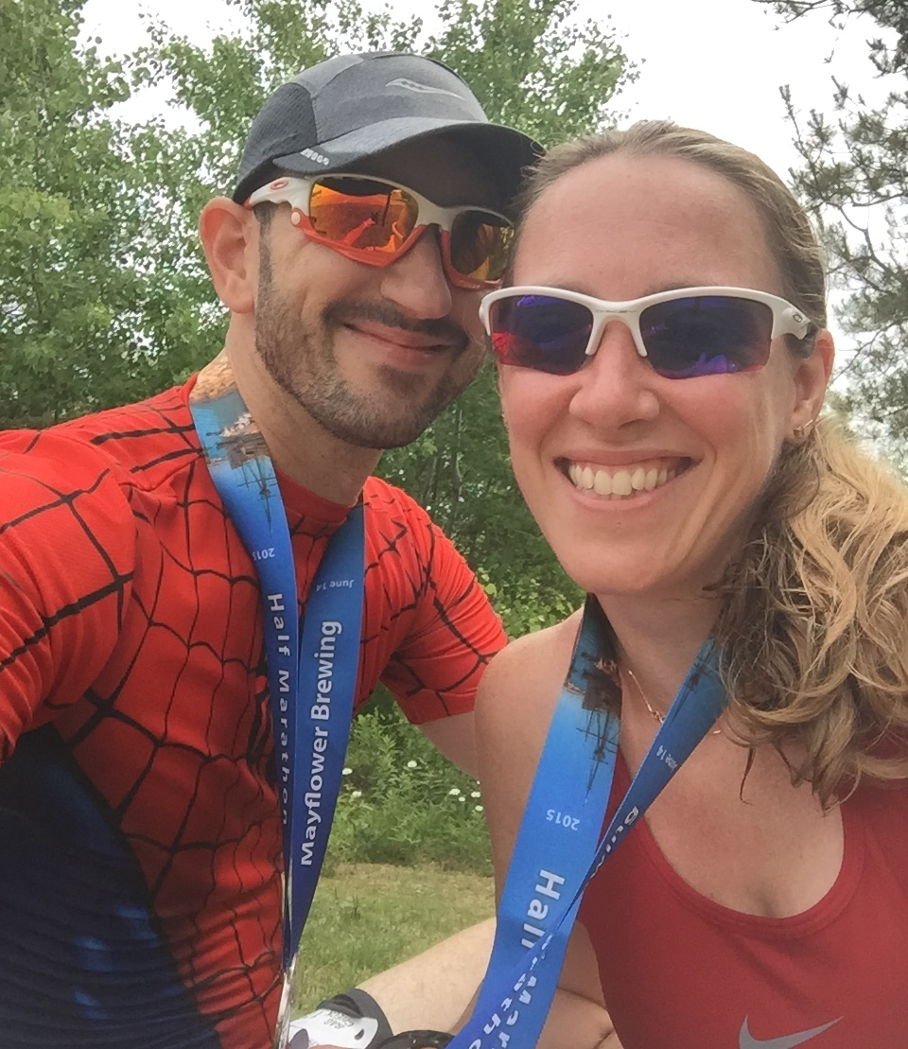
Mark McCarty and Hillary Lawrence - June 14, 2015

Pre Race/ Post Beer
In the summer of 1997, Hillary was an 18-year-old waitress at the local hang-out and Mark was a 22-year-old warehouse worker that came in for a coffee after a long shift. She brought him coffee and the two shared glances. After a few weeks, he got the courage to write his number on the back of the tab. They dated for the summer, then Hillary returned to college while Mark embarked on a career in sales.
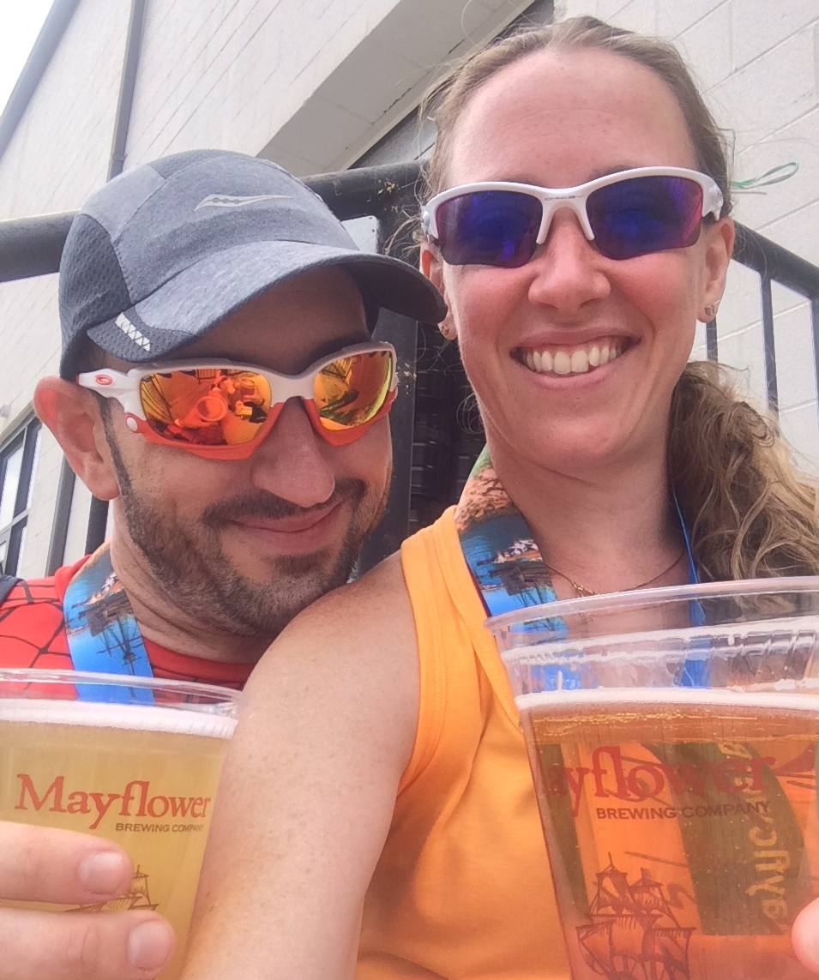
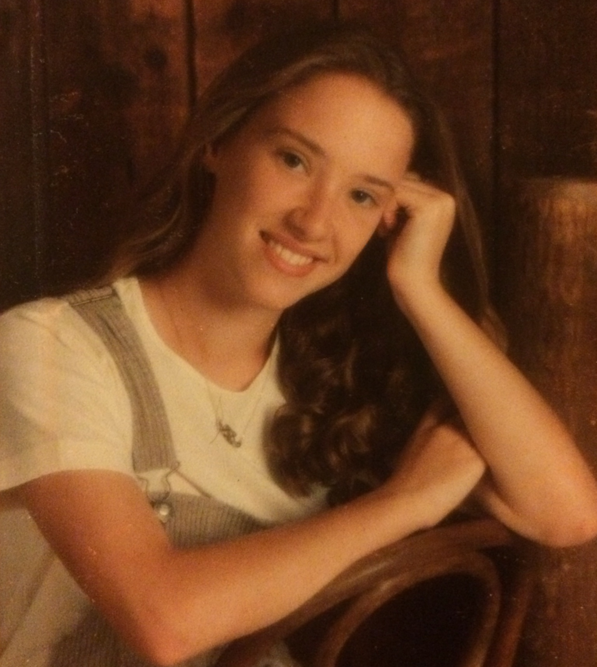
Fast forward to June 2012, when Hillary sought him as a friend on Facebook. They lived in different states and were both married with children. Mark posted about running, and it inspired Hillary to give it a try. As time passed, they shared photos of their children and their races.
Mark, 1996
Mark, 40, and Hillary, 36, enjoying the spoils after the Mayflower Brewery Half Marathon 2015
Hillary, 1996

By 2014, both were in the throes of their individual divorces and reached out to each other to go for a run. Runners know that running and talking with a friend is cathartic, but unexpectedly, this run rekindled an old flame as well. After 18 years, they both still made each other’s hearts skip (no running pun intended).
“It was just supposed to be a run where we could vent about our separate lives.” said Hillary
“But when I saw her, the feeling was the same and the passion was the same. I had missed her.” said Mark.
“It was undeniable.” said Hillary of the feelings after that fateful run.
The two continued to support one another in their struggles as divorced parents and their efforts as runners. They also enjoyed sharing their mutual love of beer, often bringing each other new brews to try. A half year passed and the two moved in together, combining a family of five children. All of the children are runners and the family of seven regularly participates in racing events for all ages.
Mark and Hillary strive to take care of the family while still finding time as a couple. When not racing as a team of seven, they plan races together as a couple that tout beer at the finish. They both enjoy cold microbrews as a reward for the miles they’ve run.
“I have planned at least 5 races this year that are about beer. All of the races are sponsored by microbreweries, like Mayflower. To me, running a race isn’t about the competition, it’s about having fun and finding personal reward.” said Hillary. The couple’s race itinerary includes a hometown race in Windsor, Connecticut, whose registration includes unlimited pints of local microbrews until the kegs are tapped - all proceeds go to the cancer charity Alex’s Lemonade Stand.
Mayflower Brewery Half Marathon Finish Line
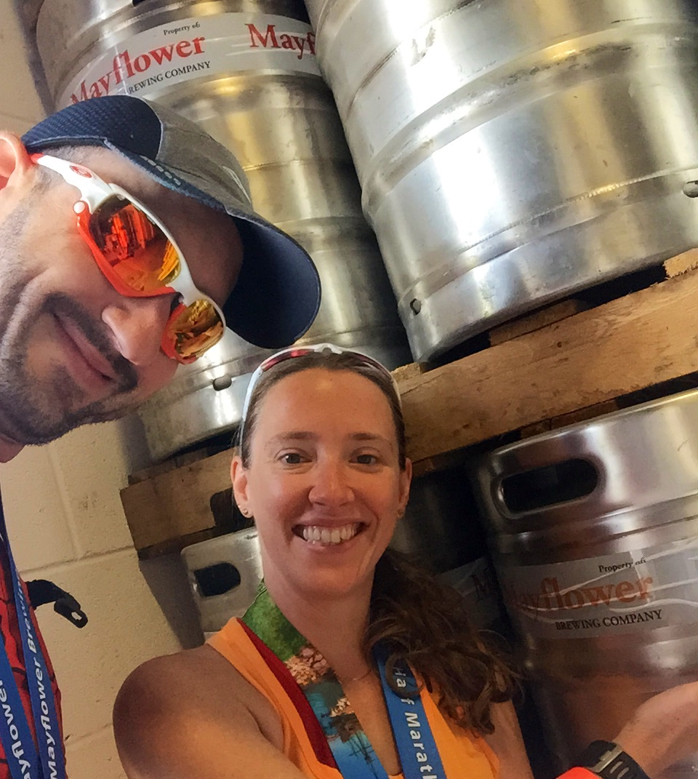
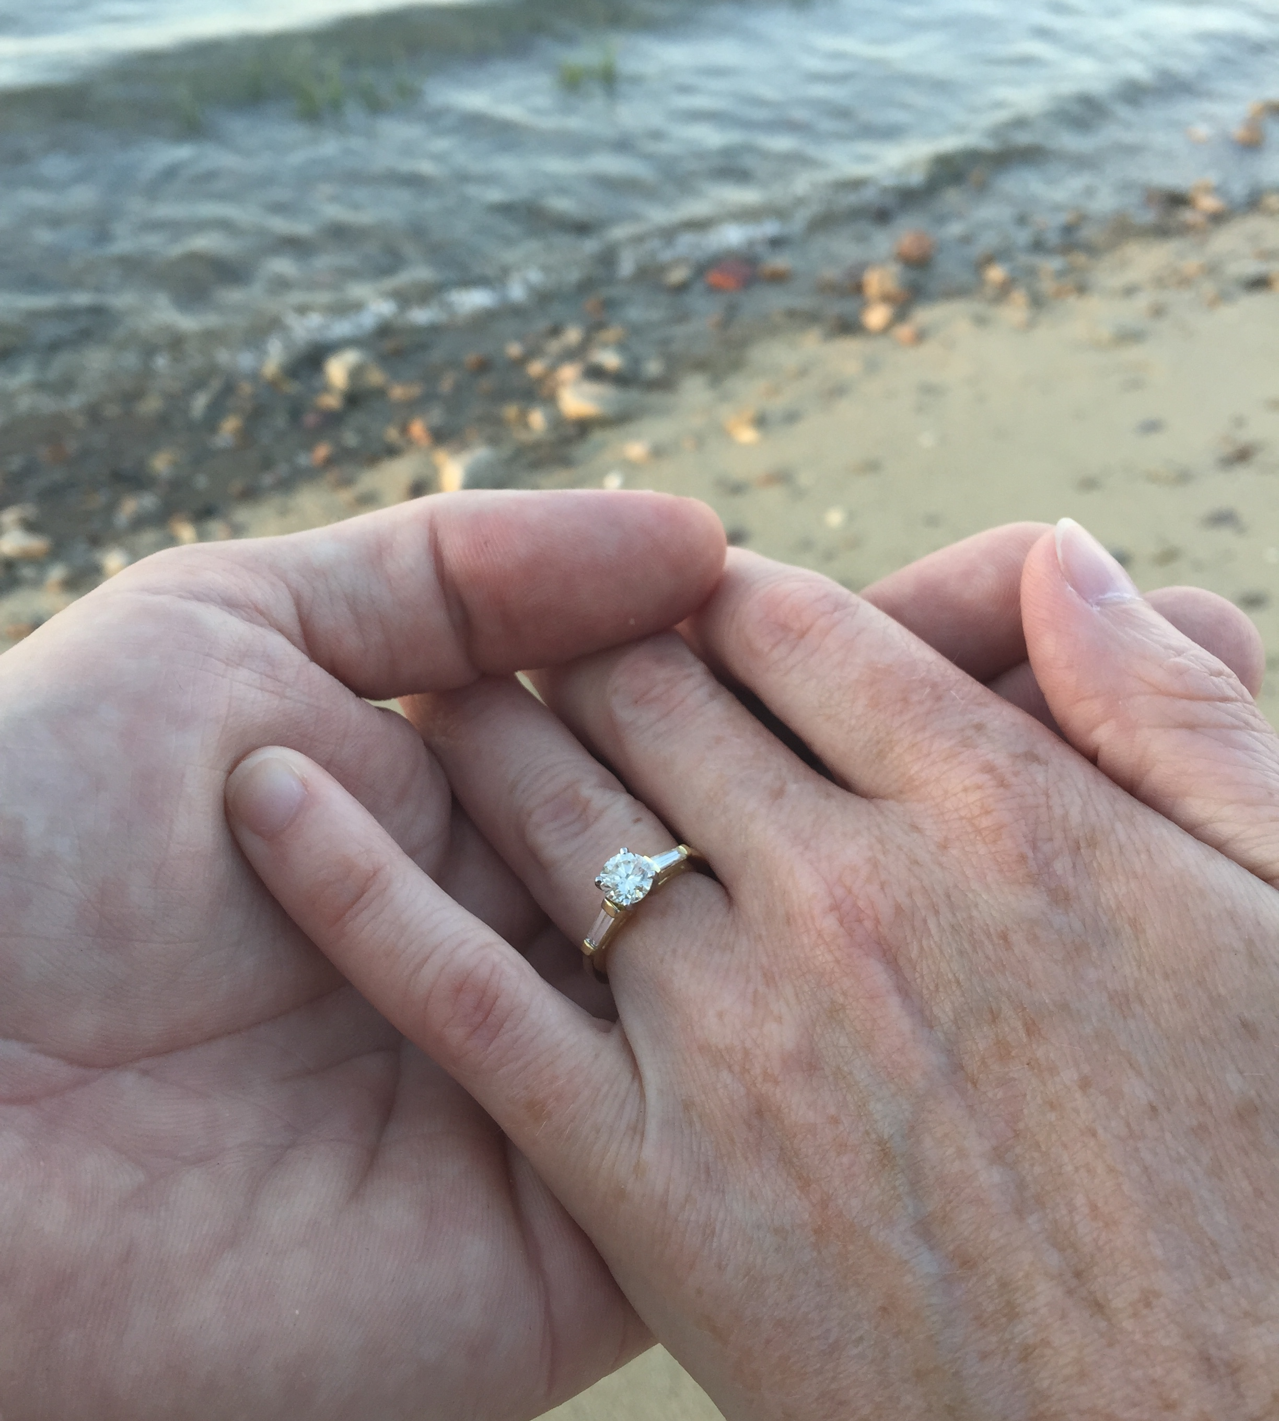
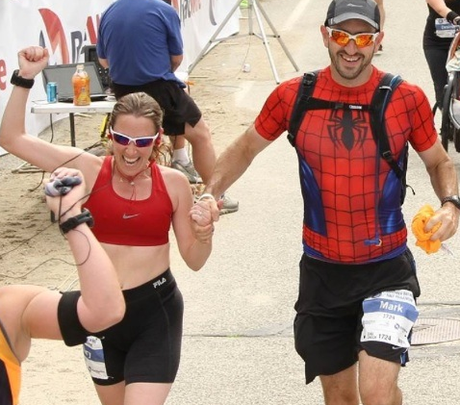
“I was so excited to find Mayflower Brewery’s race this year. Mark and I are big fans of the porter and couldn’t wait to try other styles fresh from the brewery on race day.” said Hillary. “Registration included a free stein and a free pint. What else could we ask for after 13.1 miles?”
“We will definitely sign up again next year. It was a beautiful course, it was well organized, the volunteers were very supportive, and the post race party was great.” said Mark.
The Mayflower Brewery Half Marathon was especially memorable for the couple, as Mark proposed to Hillary just 12 hours before the race.
“It was beautiful - we were on the beach at sunset. He’s amazing.” said Hillary of the proposal. “This will be like an anniversary race to us next year. See you in 2016!”

